**“Glen’s Parallax Perspectives”** is a series of TV programs offering **fresh ways for people to see issues** such as foreign policy, social and economic justice, the environment, governmental functioning, and so forth. We provide **voices and viewpoints that are rarely heard in mainstream media**.

**Mainstream media, politicians, and culture see the world in conventional ways. Therefore, in order to solve problems, we need to see things in fresh ways.** Glen Anderson created this TV series to help people see things differently so we can solve problems at all levels from the local to the global.

This series title refers to “***parallax***,” which is the view you get by looking from a different perspective. For example, put one finger in front of your nose and another finger farther away. Close one eye. Then open that eye and close the other. Your fingers will seem to move. This is called a “parallax” view. **This TV series invites you to look at issues from fresh perspectives.**

Each program airs three times a week (currently every Monday at 1:30 pm, every Wednesday at 5:00 pm, and every Thursday at 9:00 pm) for the entire month on Thurston Community Television (TCTV), channel 22 for cable TV subscribers in Thurston County, Washington. TCTV is part of Thurston County Media. You can see their schedule at [**www.tcmedia.org**](http://www.tcmedia.org)

**You can also watch the program summarized below through your computer** at [**www.parallaxperspectives.org**](http://www.parallaxperspectives.org). All episodes of “Glen’s Parallax Perspectives” are posted on this blog’s “TV Programs” part and also in one or more of the categories listed in the right side of the blog home page. Also, see information about various issues at the category headings at [**www.parallaxperspectives.org**](http://www.parallaxperspectives.org).

Glen Anderson (360) 491-9093 **[glen@parallaxperspectives.org](mailto:glen@parallaxperspectives.org)**

**🡪 This document provides a little more information than we could squeeze into the one-hour TV program. I encourage people to watch the interview and also to read this document for additional information and links to more sources of information. This document ends with a great list of sources of information.**

**🡪 I saved this document in Word format with live links.** If this document does not load or print properly for you, please e-mail me at [**glen@parallaxperspectives.org**](mailto:glen@parallaxperspectives.org) and I’ll promptly send you the links you request.

**🡪 Please invite other people to watch this video and/or read this thorough summary through these parts of my blog,** [**www.parallaxperspectives.org**](http://www.parallaxperspectives.org)**, including the categories for “TV Programs” and “Economics” and “Climate.”**

**“Pension Funds Must Sell Fossil Fuel Investments”**

Glen’s Parallax Perspectives TV Series

November 2023

Glen Anderson (360) 491-9093 [**glen@parallaxperspectives.org**](mailto:glen@parallaxperspectives.org)

**Glen welcomed viewers and introduced this month’s topic and guests:**

Glen said this month’s interview in the “Glen’s Parallax Perspectives” series explores an important aspect of the climate crisis that most people have been neglecting. He said that if people learn about this aspect – and take necessary actions – we can protect the climate and also protect ourselves from financial losses.

He said our strategies for protecting the climate must go beyond changing specific public policies in order to reduce burning fossil fuels. We also need to **stop “the money pipeline” that funds fossil fuels and the climate crisis. One way of doing this is to urge all kinds of entities to sell their investments in fossil fuels.** Many mutual funds, investment funds, foundations, universities, big religious organizations, and other entities need to sell their fossil fuel investments.

For this TV program, Glen interviewed two local experts who are working to convince the Washington State agency that manages public employees’ pensions to divest from fossil fuels. Both of these women have been working with Climate Safe Pension Network more than a year.

• **Donna Albert** is a retired Professional Civil Engineer, and LEED Accredited Professional, with a Master’s degree in Civil Engineering. She worked 27 years as an engineer for the State of Washington. This included 12 years managing capital construction, and 15 years as an energy engineer providing energy retrofits for the buildings at agencies, colleges, municipalities and school districts.

• **Kristin Edmark** has a master's degree in Public Health. She has worked as a hospital dietitian and as a science teacher. For four years she fought to prevent a climate-disrupting methanol refinery from being built in Kalama, Washington, near her home. When she learned that Washington State pension funds would be used to build the methanol plant, she joined with Donna and other peoples in providing written and oral comments to the Washington State Investment Board to urge that state agency to stop investing our pension money in fossil fuel projects. She also collaborates nationally through Climate safe Pension Network.

Glen welcomed Donna and Kristin and invited them to share their deep knowledge and their smart recommendations during this TV interview.

**Glen provided some basic information about the climate crisis:**

In order for everyone to understand the context for this interview, Glen provided some basic information so everyone – including people who don’t know much about the climate crisis – will understand what our guests will be explaining.

He said that worldwide – and in our local region – climate disruptions have been increasing in number and in seriousness. Burning fossil fuels pollutes our atmosphere with carbon dioxide that disrupts climates in radical ways. Climate disruptions have been causing extremely serious problems in various places, including droughts and wildfires – extremely heavy rainfall and floods – vastly more destructive hurricanes – destruction of buildings – destruction of agriculture crops – starvation and migration in areas that can no longer grow food –the list goes on and on.

The term “climate change” is too timid and not accurate. **It really is “climate disruption” and “climate chaos,”** because that’s what this crisis really is.

Also, he said it’s not some abstraction called “the climate” that causes the problems: **the problems come directly from burning fossil fuels**, such as coal, oil and natural gas – and directly from methane coming from several sources.

He said scientists have been loudly and repeatedly saying **we must IMMEDIATELY AND SHARPLY REDUCE our burning of fossil fuels**. But businesses and governments at all levels – global, national, state and local – keep **FAILING TO TAKE NECESSARY ACTIONS**. We’ve taken a few good actions in Washington State and in our local communities, but we must take much stronger actions here. Our national and global levels are **GROSSLY NEGLIGENT**, he said.

Besides sharply reducing the amounts of fossil fuels we burn, scientists say **WE MUST STOP NEW FOSSIL FUEL PROJECTS**.

He said today’s TV program provides important information about some ways to mobilize economic pressure to **STOP INVESTING IN FOSSIL FUEL PROJECTS**. Many people who want to protect the climate would be alarmed to learn that their pension funds and other financial assets are actually **FINANCING THE DISRUPTION** of Planet Earth’s climate.

**The ”Carbon Crunch” graph shows we must quickly reduce emissions:**

Glen showed on the TV screen an image he had showed when we produced a TV program on this topic in 2018. Donna and another expert were guests explaining the need to promptly reduce climate emissions and sell investments in fossil fuels.

This image (now shown on the next page) was created in **2016** and urged an **immediate** sharp reduction in climate-disrupting emissions then – in 2016 – and said that if the world waits until 2025, the slash in emissions will need to be a radically steeper decline. See the slopes on this image.

**Now – at the end of 2023 -- we have NOT YET STARTED transitioning anywhere near boldly enough!**

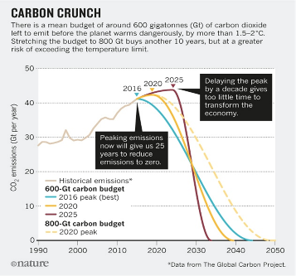

Donna said this graph was presented to the American Geophysical Union in 2017. The expert who presented it was urging an ambitious peak and decline for 2020. (*See the yellow line*.) He called for a rapid transition off from fossil fuels. Donna said the yellow line running down from 2020 proposes emissions to cut in half by 2030 and reach zero emissions in 2040. She said when that expert presented this graph in 2017, he was proposing a 20-year transition to stop all fossil fuel emissions from 2020 to 2040.

Donna invited us to see this graph as a “budget.” If you spend your bank savings too quickly, your money will run out sooner than if you reduce your spending. She said this “budget” analogy urges us to quickly peak and start sharply reducing the emissions we “spend” into the atmosphere. The sooner we peak and start reducing, the longer we will have to transition off from fossil fuels.

But we failed to peak when experts told us to. In fact, we have been burning more and more (except for a brief dip during the COVID crisis. She asked us to see the maroon-colored line showing a peak in 2025. This is only a little over one year away. Peaking in 2025 would require an extremely sharp decline in emissions in order to finish “spending” all of the emissions in our “budget” in order to stay well below the 2 degrees Celsius limit that would cause extremely horrible damage to all of us. She said if we cut emissions in half between 2025 and 2030, we would still have to cut the other half by 2035.

Glen said people can see the graph’s stark warning that – since our society has delayed peaking – the transition that is absolutely necessary will be much, more difficult than if decision-makers had acted responsibly in previous years. He said all levels of government and business are still in denial and keep refusing to take actions that are necessary to save Planet Earth.

**The climate crisis means everyone must quickly sell investments in fossil fuels:**

Glen explained briefly why everybody needs to quickly sell their investments in fossil fuels.

He said fossil fuel companies have made themselves fabulously wealthy by promoting the burning of fossil fuels.

We must counter those economic forces with smart strategies in the opposite direction.

A powerful strategy for quickly transitioning away from burning fossil fuels and boldly emphasizing conservation and alternative energy would be to STOP FUNDING fossil fuel projects. Despite the rapidly worsening damage to the climate, more oil and gas drilling, fracking, pipelines and other big projects are **still being built!** We must STOP INVESTING in fossil fuel projects that disrupt our climate!

Although we are making some progress toward transitioning to clean energy, fossil fuels are still dominating us.

He said that when we were preparing for this interview, Kristin told him that the problems will not take care of themselves. Therefore, he told our TV viewers that we cannot just leave this up to “the free market,” because “the free market” is what caused this problem! The people with political and economic power will keep making problems worse.

He asked Kristin what she recommends people – including our TV viewers – should know about this.

Kristin agreed with what Glen said. She explicitly named greed as the source of the problem.

Kristin urged people to find out what their pension funds are investing their money in. She said the big fossil fuel companies want to get every bit of money they can extract from what they own.

She said those companies really do know they are responsible for disrupting our climate. They know they are causing floods, droughts, sea-level rise, and other problems. They have been lying to the public. Their lobbyists lie to the government.

She added that the Secretary-General of the United Nations – Antonio Guterres – said investing in fossil fuel infrastructure is “moral and economic madness.”

Glen said that when he showed the powerful graph a moment ago, he mentioned that he had interviewed Donna and another expert for his April 2018 TV program about divestments. That episode’s title is: “Sell Off All Fossil Fuel Investments Now.” He posted it to his blog so people anywhere can watch it at any time. Besides posting the April 2018 TV video, he also posted a thorough summary of what we said, along with a list of many sources of information.  Visit his blog, [**www.parallaxperspectives.org**](http://www.parallaxperspectives.org) and click “TV Programs” or “Climate.”  Look for that TV episode’s title, **“Sell Off All Fossil Fuel Investments Now.” The direct link is:** [**https://parallaxperspectives.org/tv-sell-off-all-fossil-fuel-investments-now**](https://parallaxperspectives.org/tv-sell-off-all-fossil-fuel-investments-now)

**Fossil fuel investments have become risky, so everyone needs to sell them now:**

Glen said both Kristin and Donna know that – besides hurting the climate – fossil fuel investments also have become **risky** investments. He said people still assume that oil companies are “blue-chip” stocks. No!

They have become **risky** investments because we must sharply reduce our burning of fossil fuels, as shown in the graph we showed a moment ago. This reduced demand will financially hurt the fossil fuel companies.

Many coal companies have already gone bankrupt. Oil and natural gas companies are at risk too. Smart investors have been selling their fossil fuel investments because have become risky investments that will lose value.

Kristin and Donna provided two graphs that we showed next on the screen, so you can see for yourself the problems. You can see these graphs on the next two pages.

The first graph shows that while the economy overall is starting to transition to clean energy, the fossil fuel companies are NOT transitioning.

Below the vertical bar graph, see what each color means.

**The very tall light blue bars** show “capital expenditures” (investments in fixed assets such as new wells, pipelines, refineries, etc.) for oil and gas.

**Immediately above** the light blue bars, see **the very, very tiny dark blue** “capital expenditures” for low-carbon projects in 2021-2022. Kristin said they invest only a tiny – negligible – amount in renewables.

Donna added that oil companies’ ads on TV football games exaggerate this tiny amount and mislead the TV audience into thinking that they are financing clean energy, when they really are stuck in the bad status quo.

Glen agreed with Donna that they are propagandizing the public to make us think they are on our side when really they are not.

**Above that, you can see a light green** measure showing ever-growing dividends, stock buy-backs, etc., that further enrich the owners instead of helping solve the climate crisis. These companies are so rich that they can afford to buy their own stock back with their huge profits nowadays. Their demand for buying their own stock reduces the amount of stock outstanding and artificially increases the stock price for the benefit of current owners. (Thanks to Kristin for clarifying this during our interview.)

**The top part** of the bars for 2021 and 2022 show “net debt repaid.”

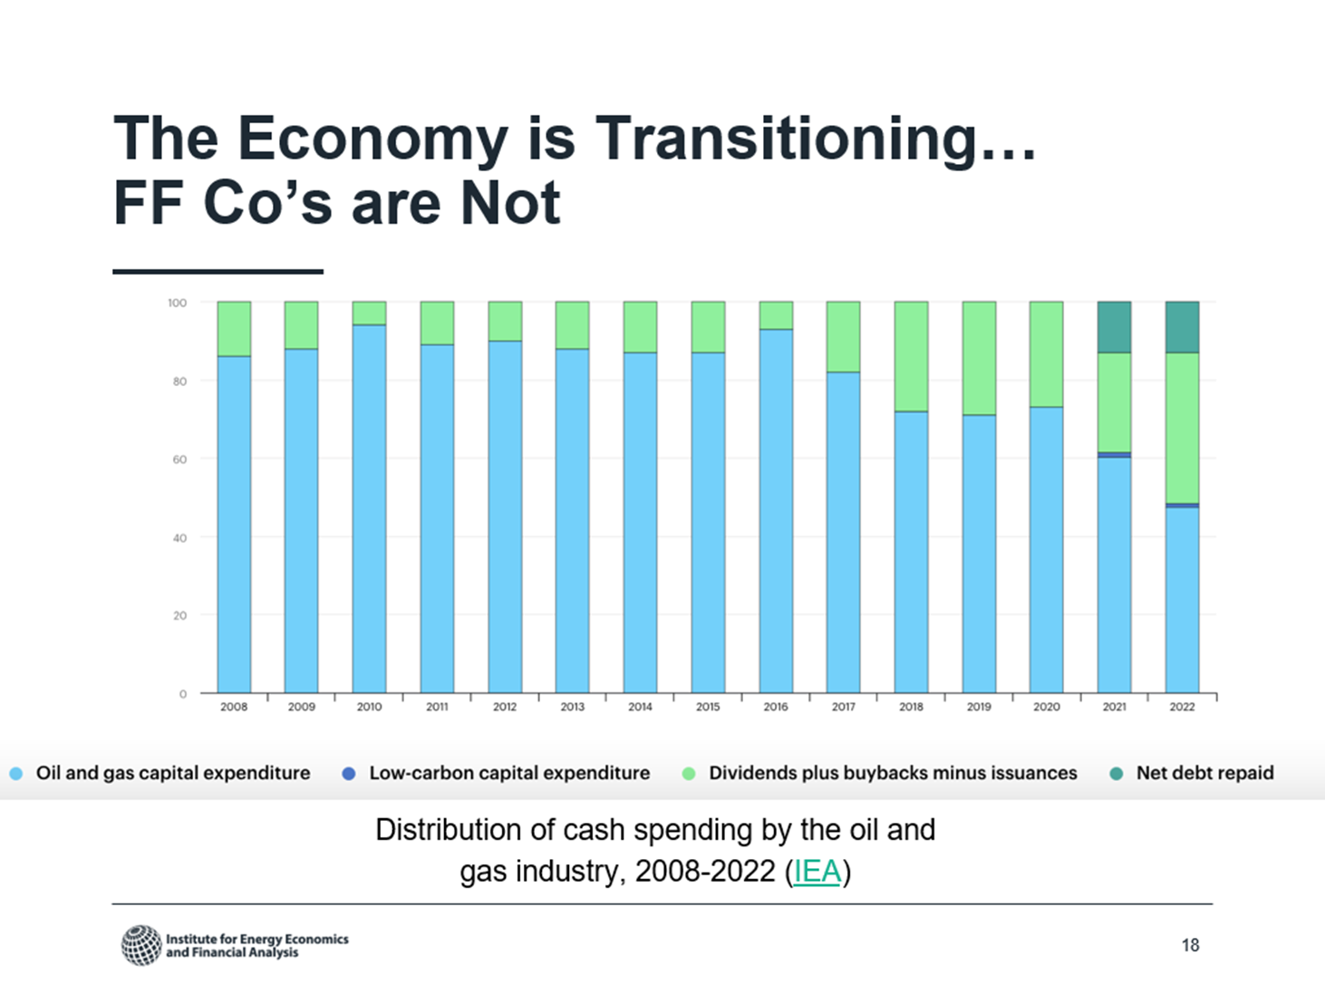

Glen said Standard & Poor’s (“S&P” in the graph below) is an entity that rates the stock performance of big businesses, including 500 of the biggest companies listed on stock exchanges.

He said their composite of “returns” (profits) for the past 10 years showed + 222% for their composite of 500 stocks, but only 27% for the “energy sector” companies among them. See the wide gap between the blue and red lines in this graph:

Donna had provided this graph and said Glen’s summary is accurate. She said those big energy stocks have not been good investments lately. She said they will get worse and worse as we transition from fossil fuels to clean energy. Donna said the energy line here is almost all fossil fuels.

Glen agreed that the gap has widened in the past decade. Our pension funds should pay closer attention to these facts.

Donna said some recent studies have examined whether pension funds would have been better off recently if they had not invested in fossil fuel companies. She said many pension funds actually lost money on their fossil fuel investments in the past decade.

Glen expressed great appreciation for how well Donna and Kristin have been researching the facts. He said they really are “on top of this stuff.” He said we will explain later in the interview that the people managing public employees’ pensions in the State of Washington are not as savvy as Donna and Kristin are.

Donna did not agree with Glen’s most recent statement. She said overall the people managing public employees’ pensions in Washington have done very well compared to other pension funds. However, on this one topic, they have been wrong. She said we can get out of fossil fuels and still have a good, strong pension fund, because fossil fuels are not doing well.

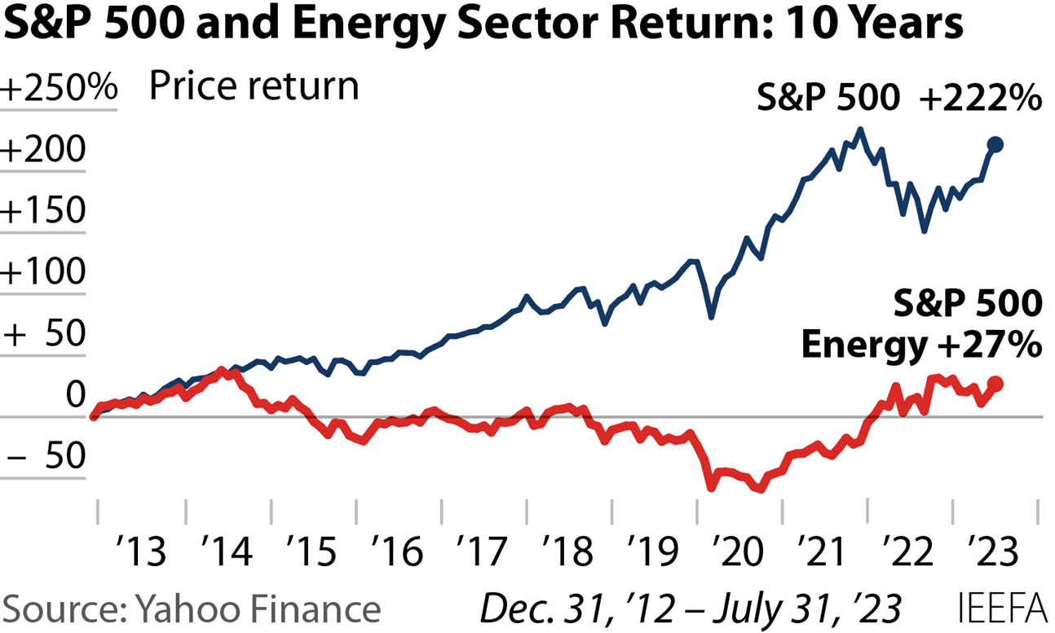

Next, (after the TV screen was black for a few seconds), we showed a cartoon provided by one of our guests. This cartoon shows the irony we are discussing. In the future, this is what the adults will be telling the kids around the campfire.

Donna thanked the artist and said we are using his cartoon for educational purposes, so she will buy one of his coffee mugs as a way to think him.

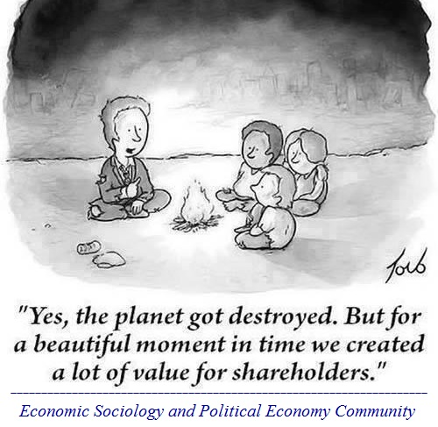

Glen said the risks we are discussing pertain to EVERY individual and EVERY investment fund, including pension funds. This problem is important for:

(1) Our own individual investments, mutual funds, and so forth.

(2) Our pension funds

(3) Investments by our national level religious organizations, our college and university endowment funds, and so forth

If you are enrolled at a college or university in the U.S., your tuition is likely to be fueling the climate crisis. If you donate to their endowment funds, you are probably fueling the climate crisis. Students at many colleges and universities have won this battle and convinced them to divest.

You can click this link to demand that colleges and universities divest from fossil fuels. [**Sign your name here to demand that colleges and universities divest from fossil fuels!**](https://click.actionnetwork.org/ss/c/P8Elou2Rvc0qoMPEUZrMXcOpy_XqN4R2ZGjoK-5zZnnCXtXkQ8Sx2lURC1p7SkhyoxEKdlJeHe89hz7NTIvd4tskrOl_ATnSVJR3o31QbalgrySxtDPZ-nQYYTx5F9_v4mr0Mw1n15L_xfcG20pj5061yt6f4GRjXqRg8PNfmaIxxAbKY2OQDL5je4Ai6xTg2caOfOQnIX00jHZqi4Z8JPKYO1KOqAAtYQMiDESwtrSPtul_HzrMh30KXQvIeZd5VRASZzh0EAgHcNEgIv7WwsoQgiXvmNcpEzypkNondy1GuZLV5XqhN6upStqdyyEoS-mTiP3q0h2qqk3DP-KgbLgpCp2YDf5qt5rnbyiqGxa8dqdDZR8YPWuq4Oxdt_U43vp6b4LBKvo2b2RPzVa6h5tM7z-Xw2-vosT-RgvnpOQkdZzDQSj7582wWTRsCc3WLOVOn8AfEjJIALdo-cYtW6W4MPdecw1RtwwpUWfgiqqrjHnYrvCjl8J2nXc4sXBWwiovIWcokTbezdz23RznCuEp7I8kgAv0uPfwm63M1HFt-prZE_Dm2yNhf89FG4Bd/3zy/yc6Nb6p4R4GN-2Rde5f_zQ/h0/Vj4ZviggP_5XDUte_0ycGUIsxf5Pw6pZbHmsYeZpcSQ)

Glen said students at Seattle University organized and accomplished divestment! The students discovered that 6.1% of their funds were invested in fossil fuels. The students organized, identified the persons responsible, and focused student pressure until they won. See this: [**http://divestsu.weebly.com/**](http://divestsu.weebly.com/)

The **“Sources of Information”** section near the end of this document will provide more information about opportunities and progress to get colleges and universities to divest.

Glen said divestment is a powerful tool! A few decades ago when the racist white minority in South Africa imposed brutal apartheid upon that nation’s black majority, a worldwide movement arose and grew to pressure businesses into divesting from South Africa. That divestment movement’s economic pressure helped to abolish apartheid.

**Pension funds need to divest:**

Glen said the rest of this TV program focuses especially on the need for pension funds to divest from fossil fuels. Many business corporations have pension funds for their employees’ retirement. Many levels of government also have pension funds.

We will focus especially on the State of Washington, but these principles apply widely to other governments and businesses too.

Kristin said public employees’ pension funds in Washington, Oregon and California have many billions of dollars:

* Washington’s fund invests $8 billion.
* Oregon’s fund invests $6.6 billion.
* California’s fund invests $14 billion.

This adds up to nearly $30 billion that is financing new fossil fuel projects.

Washington also invests in other big businesses (J.P. Morgan Chase Bank, for example) that invest heavily in new fossil fuel projects.

**Washington State Investment Board (WSIB) needs to divest:**

Glen expressed appreciation for both guests’ skilled work on these issues in relation to the public employees’ pension fund in Washington State.

He invited Donna to introduce our TV viewers to this aspect of our topic before our guests explain specific problems and recommend smart solutions to those problems.

Donna said retirees have been alarmed that the Washington State Investment Board (WSIB) has been investing in fossil fuels. For about a decade now, a number of us have been going to the WSIB’s meetings and talking with them about the problem. She said recently we have been wondering why the good people on the WSIB have not been getting out of fossil fuels. She said we have been talking to them – and listening to them.

She asked Kristin to discuss the slides that we next showed on the screen to give our TV viewers the necessary background information before we presented more information about problems and solutions.

Kristin said in Washington State, the state employees and many municipal employees, including firefighters and teachers, have pensions managed by the WSIB. The City of Seattle and a few other jurisdictions are exceptions.

She said any public employee could ask their personnel or human resources department if WSIB or some other entity is managing their pensions.

Here is some basic information about the WSIB that failed to appear on the TV screen, but Glen is including it now in this document on the blog::

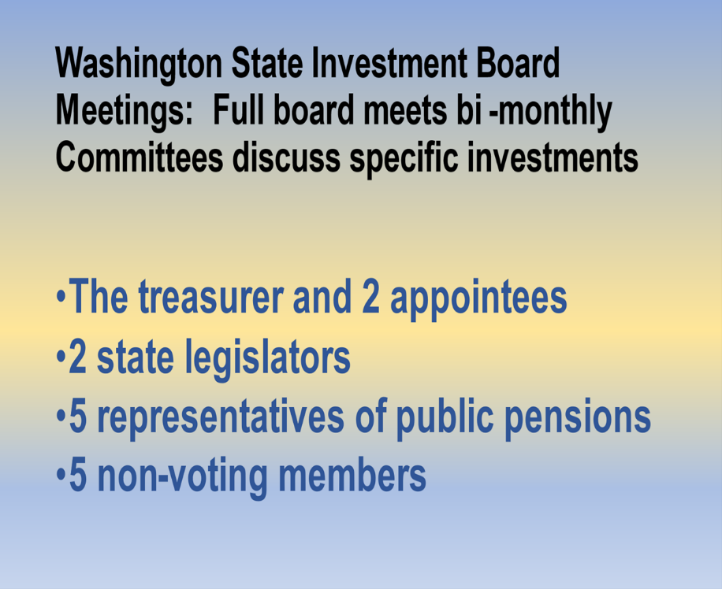

Go on to the next page to learn about WSIB’s investments in fossil fuels.

**WSIB’s bad investments hurt the environment and climate:**

Next we showed on the TV screen this image about the WSIB’s investments in fossil fuels as of June 30, 2021. Kristin said it’s important for people to see this because it reports on a huge number of billions of dollars. Many people don’t know the names of these huge fossil fuel entities in which the WSIB invests.

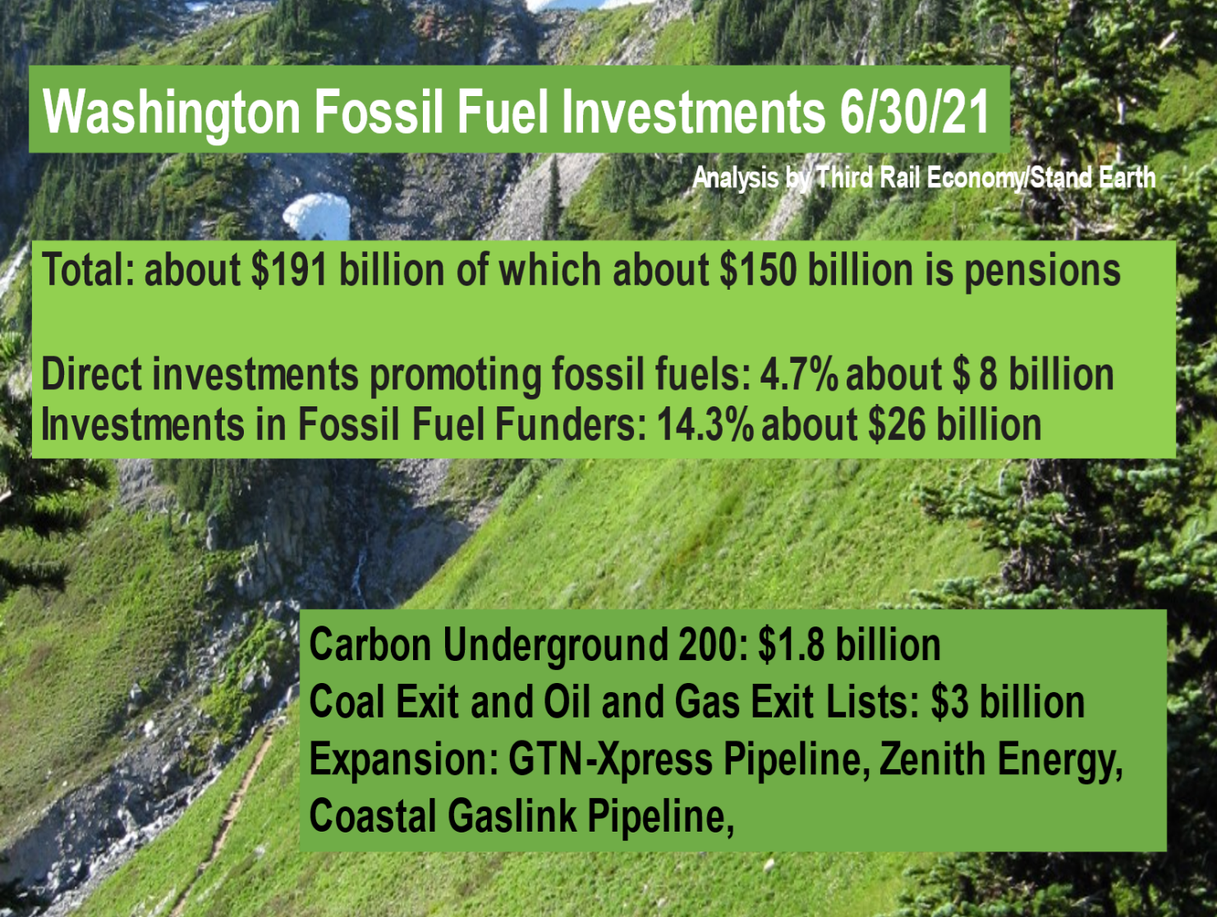

Glen said that when he introduced Kristin at the start of this TV interview, he said she worked to prevent a giant methanol plant from being built in Kalama, a town on the Columbia River in SW Washington, near where she lives. The Washington State Investment Board (WSIB) was investing our pension funds in that – and in some other horrible projects that would hurt the climate. Those include a huge project owned by Puget Sound Energy (PSE) that is building a huge Liquified Natural Gas (LNG) pant in Tacoma.

Kristin said WSIB also invests in TC Energy, which is building the GTN Express pipeline that will carry natural gas through the Pacific Northwest, but really it is not needed. Glen said PSE is a multi-national capitalist utility company that sells electricity and natural gas to a number of counties in Washington State.

He also said that when we were preparing for this interview, Donna told him that WSIB has invested our pension money in the Rio Grande Liquified Natural Gas project on Texas’ coast. When a French bank stopped financing it, WSIB provided $400 million through a greedy, nasty private equity company called KKR.

Donna said we were surprised to learn that WSIB had invested in the Rio Grande LNG project. She quoted something from the famous climate scientist and author Bill McKibben. He had written that if the LNG buildout continues here, in Canada, and in Australia, “its sheer size will overwhelm our efforts to rein in global warming.” She said one of the projects that McKibben denounced is 20 times as huge as the Willow Project, a massive oil drilling project President Biden approved to occur on Alaska’s northernmost coast.

Donna said there are many LNG plants, and she mentioned the Rio Grande LNG project to provide an example of WSIB’s investments of actual projects that will seriously hurt the climate.

Glen added his concern that LNG is horrible for many reasons that we don’t have time to discuss here, but people do need to know that Joe Biden, who ran for President in 2020 with many promises to protect the environment and climate, actually approved the Willow Project to drill for more oil, and he also has actually been aggressively promoting more LNG exports from the U.S. to other countries. President Biden is violating his campaign promises. He said we need to keep an eye on the federal government as well as state and local governments.

Kristin added that LNG – Liquified Natural Gas – is nearly all methane. She reminded us that methane is many times more disruptive to the climate than carbon dioxide is. Glen said the term *natural gas* is basically just a euphemism for *methane*. He said fracking for oil and natural gas causes enormous amounts of methane to be released from underground. He said the natural gas companies keep trying to fool people into thinking that it is a transition from oil to clean fuels. It absolutely is not!

**WSIB hides the truth from us – and tries to avoid accountability:**

Glen said that in order to accomplish any goal, people need accurate information. Unfortunately, the Washington State Investment Board (WSIB) has failed to provide the open and transparent information we need. This makes it hard for us to hold them accountable. But we are persisting.

He invited Donna to share some information and insights about the WSIB’s lack of transparency and their failure to provide accurate information about what they are doing with our money.

Donna said the real villains are the fossil fuel companies, because for decades they have been deceiving the general public – and the government and investors. She said that in addition to lying, the fossil fuel companies have used their money to influence elections and to slow the transition off fossil fuels. She said the financial industry in general and public pension funds such as the WSIB have been – and still are – strongly influenced by this intentional deception. They might not even be aware of this deception.

She said that overall the WSIB has been doing a good job of managing our pensions. She said that the WSIB is transparent in that they list all their investments (which they call “holdings”) on their website each year. However, they are not very transparent in disclosing how their holdings affect the climate. She said it is very difficult for an ordinary person like her to look at that list of holdings and figure out how much fossil fuel money is in it. Some other analysts (such as those who help the **Climate Safe Pensions Network,** [**https://climatesafepensions.org**](https://climatesafepensions.org)**)** have been able to figure out some estimates.

Also, she said that about one-fourth of WSIB’s holdings were invested in “private equity funds” and other giant collections of investments that are not transparent at all. They do not let the public know any specific information. She said this is where WSIB’s $400 million investment in the Rio Grande LNG project was hidden. She said the only reason she and our friends found out about this was someone investigated this at the Private Equity Stakeholder Project ([**https://pestakeholder.org**](https://pestakeholder.org)) and told us about it.

Glen said the term “private equity” refers to giant businesses that hold huge investments in other giant businesses. They are secretive about what they put money into, so we lack transparency at several levels. We can’t discover the truth because of several levels of corporate ownership of other corporations that hold other corporations, and so forth. He said this prevents us from finding out about the bad stuff they are doing – unless some clever people really dig into it.

Glen added to what Donna had said about oil companies actually lying to us. He said California’s state Attorney General sued some oil companies about their fraudulent business practices and deceptive advertising. **We did not have time to say this information:** Donna sent WSIB information about the lawsuit California’s Attorney General has filed against American Petroleum Institute, Exxon, Chevron, Shell, BP and ConocoPhillips to make them pay for the damage they have caused in California. See more information here: [**https://oag.ca.gov/news/press-releases/attorney-general-bonta-announces-lawsuit-against-oil-and-gas-companies**](https://oag.ca.gov/news/press-releases/attorney-general-bonta-announces-lawsuit-against-oil-and-gas-companies) The AG’s complaints include:

* + Public nuisance
  + Damage to natural resources
  + False advertising
  + Misleading environmental marketing
  + Unlawful, unfair and fraudulent business practices
  + Products liability

Glen said people know the term “whitewashing.” It means using propaganda to paint over a problem so it is no longer visible. When those kinds of deceptions are done to **environmental** problems – pretending to care about the environment while actually failing to solve the problems – it is called **“greenwashing.”** In order to protect the climate, we need to expose the “greenwashing” that fossil fuel companies have been using to deceive people about their failures to protect the climate – and their actual behaviors that make the climate crisis even worse.

He said both Donna and Kristin have told him that WSIB has a so-called “Climate Blueprint,” but it is not what people might think it means. It is NOT a plan to reduce climate emissions.

Donna agreed that it is NOT a plan to reduce emissions. She explained that perhaps WSIB board members might have intended that having their staff create the “Climate Blueprint” to become a first step toward good action for the climate, but it does not do that.

She said that a climate “plan” is usually a plan to actually reduce emissions by setting goals, taking actions toward reaching those goals, measuring progress, and publicly reporting on that progress. That is NOT what WSIB’s “Climate Blueprint” is. She said she believes the WSIB is inadvertently mislabling this document.

Before we conducted this interview, one of the guests told Glen that the Climate Blueprint’s wording is vague, and that it does not exclude any potential investment choice, regardless of how badly it would **hurt** the climate. Instead, the guest told Glen that this document instructs WSIB to avoid financial losses **caused by** climate disruptions, such as real estate subject to coastal flooding, or agriculture stricken by drought. WSIB’s pretention that is a climate “plan” is greenwashing.

Glen said that sometimes when we have urged the WSIB to sell fossil fuel investments, they say they want to keep them so they have what they call “a seat at the table” at the fossil fuel companies – and so they can raise issues there through what they call “constructive engagement.”

Kristin said that a fossil fuel company’s primary business is producing and selling fossil fuels. They do NOT want to reduce the fossil fuels that keep making them rich. She said one of the slides we showed early in this interview *(see page 5 above)* shows that they are NOT investing in clean energy. They are trying to delay a transition to clean energy. We need to understand that “constructive engagement” and proxy voting at their corporate annual meetings is NOT doing anything to solve the problems.

She added that we learned from Stop the Money Pipeline ([**https://stopthemoneypipeline.com**](https://stopthemoneypipeline.com)) that in 2022, WSIB voted AGAINST all of the climate resolutions (except for one person). WSIB keeps voting **AGAINST** the climate.

**We have been urging WSIB to divest for 12 years now, but they keep refusing:**

Glen said that for about twelve years climate supporters (sometimes including him) have been urging WSIB to divest. They keep failing to do that. The Board members listened politely and then said they would not take our advice because they follow the advice of their own investment advisors.

He said we want to protect the climate and protect our pensions, so we want the WSIB to make decisions consistent with both goals. He said investments that make the climate worse have become risky and, he said, frankly immoral.

He said before we discuss state legislation that would help, he invited our guests to identify a few ways the WSIB could improve its functioning to protect our climate and our pensions.

Kristin said it seems obvious that fossil fuel investments are extremely risky both because they do not perform as well financially as other investments and because the hard realities of the climate mean many of those investments must not be allowed to continue long enough to pay themselves off, so they must be abandoned. The term for that is “stranded assets.” Lawsuits against those investments that hurt the climate also make them financially risky. These kinds of financial risks add to the risks for our environment and climate. Selling them is simply the right thing to do, she added.

Glen said he wanted the viewers to understand Kristin’s reference to some assets as “stranded.” He said you might have an asset such as, for example, a pipeline that was built at great expense but that can no longer be used because of its harm to the environment and climate. Now this asset just sits there as an asset that can’t be used, so it no longer produces revenue. Other assets (oil wells, coal mines, and so forth) can become worthless as “stranded assets.” He said those are very bad for the businesses that own them, because they have tied up money in building them, but now they cannot make any money from what they have built at great expense. He said he hoped this explanation helps viewers understand what Kristin meant about “stranded assets.”

**We need state legislation:**

Glen said sometimes it is possible to work with governmental agencies to solve problems, but sometimes the agencies either can’t or won’t solve the problems, so we need legislation to change what agencies do.

Before we conducted the interview, our guests said that in recent years, Washington State has been a leader in climate action. They want to build upon our Legislature’s recent progress with the legislation they are recommending.

Glen showed on the TV screen an image our guests provided, recommending some state legislation that we need. (*See next page*.)

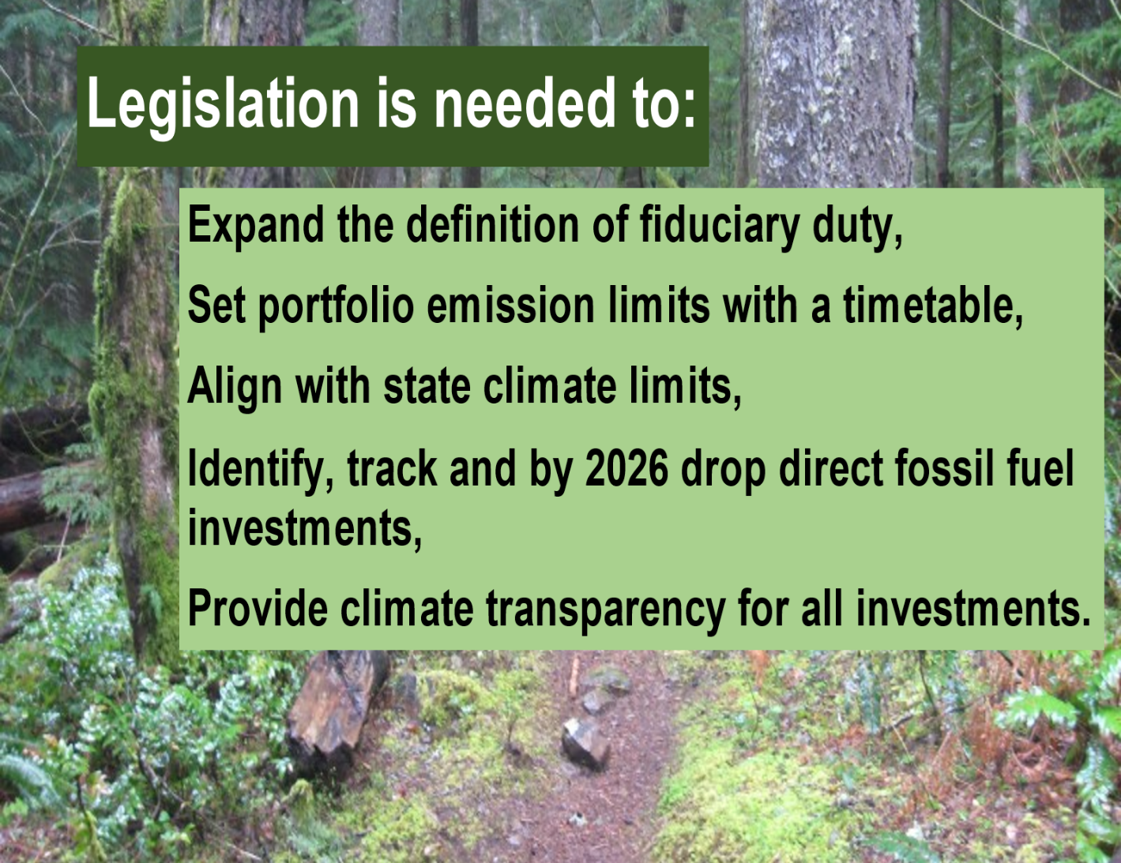

Before our guests explained this image about legislation, Donna summarized what we have learned by discussing the problem with some of WSIB’s staff and board members.

Donna said the board members are well-intentioned and dedicated public servants who are carrying out their fiduciary duties under Washington State law as they and most other people interpret it. She said the law says their fiduciary duty is to maximize the pension fund’s financial returns.

However, the law is completely silent about considering any harm to the environment or climate that those investments might cause. She added that the WSIB thinks it is contrary to their legal fiduciary duty to divest from fossil fuels. She said she and some other people think it’s necessary to change state law in order to make them consider the climate impacts and stop them from investing in fossil fuels.

Kristin said the first item in the image shown above is something the State Legislature can do. They can legally expand the definition of fiduciary duty to include considering the environment and climate impacts of investments.

Kristen added that the Legislature should also set limits for limit emissions from WSIB’s investments.

The Legislature also needs to create a timetable for measuring and making progress.

Kristin referred to another line on the image above and said WSIB’s investments are not currently aligned with Washington State’s official limits for protecting the climate, so the Legislature needs to fix that failure too.

She also mentioned the last two items listed in the image shown above. All of these things need to be fixed through laws the Washington State Legislature should pass.

**The climate crisis is a problem now in addition to the future:**

Glen said he often hears people refer to the climate crisis as something that will occur in the future. Actually, we have ALREADY been experiencing HORRIBLE DISRUPTIONS to the climate – and they have ALREADY been expensive and deadly!

He said he wants the public and all levels of government to take seriously the climate crisis as a CURRENT, IMMEDIATE crisis, instead of simply a problem for the future. That’s true regarding pensions and true for all areas of public policy. He said even our daily conversations with people also need to explicitly refer to the climate crisis as a CURRENT REALITY, not just a future problem for kids to deal with later.

He also said it is NOT O.K. for big businesses and timid government officials to make people suffer in order for some people to make money.

**We need to organizing a bigger movement for divesting from fossil fuels:**

Next he said he wants to promote the organizing that we – and other people elsewhere – have been doing to build and strengthen the climate movement – and specifically the movement to get pension funds and all other kinds of entities to sell their investments in fossil fuels.

He said that during this hour we have been talking about solving big, complex problems. **Ordinary people can indeed solve big, complex problems. We have done that many times in the past:**

* Ordinary people – led by women – organized the movement that led the U.S. to amend our Constitution in 1920 to recognize women’s right to vote. That movement took 72 years after the first nationwide convention urging that in 1848.
* Ordinary people have organized movements for civil rights and racial justice and social justice for various demographic portions of our population. They made great progress – and much more work needs to be done.
* Ordinary people organized labor unions many years ago – and that struggle continues.
* Ordinary people organized the environmental movement more than half a century ago – and it continues to expand in many ways.
* In just a few decades, LGBTQ persons have made great progress by “coming out of the closet” and organizing from the grassroots up to assert their equal rights. They shifted the culture significantly in just a few decades, so now a big majority of the public support their equal rights.
* We also organized progress in the energy sector too. He said when Gerald Ford was President in the 1970s, Ford publicly urged 1,000 nuclear power plants to be built by the year 2000, but ordinary people organized against nuclear power, and we really did stop that madness. Glen added that strong economic arguments against nuclear power plants also helped to prevent more from being built.

Glen emphasized that when we organize to protect the environment and the climate – and organize to make pension funds, universities, foundations, and other entities to sell their investments in fossil fuels – some kinds of people will easily agree with us. They are **“natural allies”** we can easily recruit. Let’s devise strategies and activities to bring them into our grassroots movement.

Some other kinds of people who are not yet paying attention to this really are **“tactical allies”** whom we could recruit to join with us if we devise strategies to show them what we have in common with their values, issues and goals. We can find ways to bring them into our divestment movement and build it into a bigger, stronger movement.

Environmentalists know that everything in an ecosystem is interconnected. Likewise, all issues throughout a society are interconnected. If the climate crisis and the economics about it are problems, what other problems have been feeding into them? What people and organizations are working to solve those underlying problems? How could we bring them into the divestment movement?

When they work on their issues, they are also helping ours tangentially – and when we work on ours, we are also helping theirs tangentially. Let’s explicitly look for the connections and explicitly identify them, so all of us can join together and make more progress in solving all of the problems we’re working to solve. This is smart organizing for “win-sin” solutions.

**Both guests urge positive actions:**

Glen said he is glad that both Donna and Kristin recognize the big problems and are promoting positive solutions and actions that ordinary people can take to join with us in solving the problems. He said we have invited ordinary people to go to the meetings of the WSIB and tell them the reasons why they should divest from fossil fuel investments.

All three of us are part of a statewide organization working on this. Donna urged people to visit our website, [**http://divestwa.org/**](http://divestwa.org/) The website includes links to good sources of information.

Glen said our group has been meeting monthly using Zoom computer video software, so we include people from several parts of Washington State – and some knowledgeable and helpful Oregonians too. He said some new people have joined with our group, and we are grateful for their knowledge, skills and good energy.

Glen expressed great appreciation and respect for the smart, effective work that Donna, Kristin, and other experts have been doing. He said they are blazing a trail that people elsewhere could follow in their respective states.

When we were preparing for this interview both of our guests approached the issue in very positive ways. Both Kristin and Donna told Glen that Washington State is a great place. They said Governor Inslee and our state legislature have made Washington a nationwide leader for protecting the climate in a variety of ways. Our state’s population includes many individuals and organizations that are doing strong, savvy work to help the climate.

Despite that positive context, it is incongruous that our state government keeps investing our pension money in fossil fuels. We really can get our public employees’ pension fund to divest from fossil fuels if we strengthen our grassroots movement for divestment!

**Sources of information:**

Glen said many excellent sources of information exist. We had time for him to mention just a very few on TV. Look below on pages 14-15 to see many more.

He recommended visiting the website for the organization for which Donna and Kristin volunteer. Visit [**www.divestWA.org**](http://www.divestWA.org) and click the link to “Resources.” See the links to some good sources of information, including [**Climate Safe Pensions Network**](https://climatesafepensions.org) and [**The Quiet Culprit: Pension Funds Bankrolling the Climate Crisis**](https://climatesafepensions.org/resources/the-quiet-culprit-pension-funds-bankrolling-the-climate-crisis/).

**3 of Glen’s TV Programs are directly relevant:**

1. Hs said when he posts this TV interview video to his blog, he also will post a thorough summary of what we said during this hour. (*You are reading it now*.) This document ends with links to the information sources listed below. To WATCH this TV interview and/or READ the thorough summary you are reading now, people can visit [**www.parallaxperspectives.org**](http://www.parallaxperspectives.org) and click either the “TV Programs” link or the “Climate” link or the “Economics” link. Then click on this episode’s title, **“Pension Funds Must Sell Fossil Fuel Investments”**
2. Glen interviewed Donna and another expert for his April 2018 TV program about divestment. That episode’s title is: **“Sell Off All Fossil Fuel Investments Now.”** He posted that to his blog so people anywhere can watch it at any time. Besides posting the April 2018 TV video, he also posted a thorough summary of what we said, along with a list of many sources of information.  Visit [**www.parallaxperspectives.org**](http://www.parallaxperspectives.org) and click “TV Programs” or “Climate.”  Look for that TV episode’s title, **“Sell Off All Fossil Fuel Investments Now.” The direct link is:** [**https://parallaxperspectives.org/tv-sell-off-all-fossil-fuel-investments-now**](https://parallaxperspectives.org/tv-sell-off-all-fossil-fuel-investments-now)
3. During today’s interview we briefly mentioned that fossil fuel companies are deceiving people with their propaganda. Glen did not have time on TV to encourage people to learn more about this by watching and/or reading a resource he posted to his blog two years ago. The September 2021 interview on “Glen’s Parallax Perspectives” TV series was titled**, “Debunk the Fossil Fuel Industry’s Phony Climate Remedies.**” It provides fresh information and insights into some aspects of the climate crisis that most people do not adequately understand. The program ends with some smart solutions to the problem. You can watch the TV video and/or read a thorough summary of what we said at this link: [**https://parallaxperspectives.org/watch-and-or-read-tv-debunk-the-fossil-fuel-industrys-phony-climate-remedies**](https://parallaxperspectives.org/watch-and-or-read-tv-debunk-the-fossil-fuel-industrys-phony-climate-remedies)

**Solid information to get you started:**

* Our two guests and Glen and other people participate in a statewide organization working on this. Please visit our statewide website, **<http://divestwa.org/>** and click the “Resources” link.
* In 2012 the great climate scientist Bill McKibben wrote a powerful article that significantly alerted people to the climate crisis. Read his article titled “Global Warming’s Terrifying New Math” at [**www.tinyurl.com/ybk55suk**](http://www.tinyurl.com/ybk55suk).
* Later, Bill McKibben’s radical idea of fossil-fuel divestment transformed the climate debate: [**https://theconversation.com/how-bill-mckibbens-radical-idea-of-fossil-fuel-divestment-transformed-the-climate-debate-87895**](https://theconversation.com/how-bill-mckibbens-radical-idea-of-fossil-fuel-divestment-transformed-the-climate-debate-87895)
* See Fossil Fuel Divestment information on Wikipedia: [**https://en.wikipedia.org/wiki/Fossil_fuel_divestment**](https://en.wikipedia.org/wiki/Fossil_fuel_divestment)
* A beginner's guide to fossil fuel divestment: A comprehensive guide to the basics of divestment: what it means, why the urgency and how it impacts climate change: [**https://www.theguardian.com/environment/2015/jun/23/a-beginners-guide-to-fossil-fuel-divestment**](https://www.theguardian.com/environment/2015/jun/23/a-beginners-guide-to-fossil-fuel-divestment)
* Climate Safe Pensions Network, [**https://climatesafepensions.org/**](https://climatesafepensions.org/)
* Glen’s blog includes a collection of information resources about divesting from fossil fuels: [**https://parallaxperspectives.org/info-resources-about-divesting-from-fossil-fuels**](https://parallaxperspectives.org/info-resources-about-divesting-from-fossil-fuels)

**More information, resources, examples of activities, etc.:**

* **Glen mentioned this resource on TV. Our guests highly recommend the Institute for Energy Economics and Financial Analysis (IEEFA)**. The Institute examines issues related to energy markets, trends, and policies. The Institute’s mission is to accelerate the transition to a diverse, sustainable and profitable energy economy. [**https://ieefa.org**](https://ieefa.org)
* The IEEFA produced this important resource: [**https://ieefa.org/resources/two-economies-collide-competition-conflict-and-financial-case-fossil-fuel-divestment**](https://ieefa.org/resources/two-economies-collide-competition-conflict-and-financial-case-fossil-fuel-divestment)
* Although the war in Ukraine has recently increased profits for the fossil fuel sector, the fossil fuel sector is still lagging behind the overall market. Here is a link to information our guests provided from the Institute for Energy Economics and Financial Analysis (IEEFA): [**https://ieefa.org/resources/taking-stock-oil-and-gas-sector-transition-sustainable-finance-proceeds-apace**](https://ieefa.org/resources/taking-stock-oil-and-gas-sector-transition-sustainable-finance-proceeds-apace)
* “If You’re Worried About the Climate, Move Your Money.” See this smart article here: [**https://www.theatlantic.com/science/archive/2023/10/climate-change-divestment-fossil-fuels/675635/**](https://www.theatlantic.com/science/archive/2023/10/climate-change-divestment-fossil-fuels/675635/)
* How to divest from fossil fuels, no matter the size of your piggy bank: Your college isn’t divesting, and your employer won’t offer fossil-free 401(k)s. Can you clean the oil slick off your retirement anyway? Sort of. [**https://grist.org/climate-energy/how-to-divest-from-fossil-fuels-no-matter-the-size-of-your-piggy-bank**/](https://grist.org/climate-energy/how-to-divest-from-fossil-fuels-no-matter-the-size-of-your-piggy-bank/)
* Stop the Money Pipeline **<https://stopthemoneypipeline.com>**
* [**https://stand.earth/our-work/programs/climate-finance/**](https://stand.earth/our-work/programs/climate-finance/)
* **Students at Seattle University organized and accomplished divestment!**  The students discovered that 6.1% of their funds were invested in fossil fuels. The students organized, identified the persons responsible, and focused student pressure until they won. See this: [**http://divestsu.weebly.com/**](http://divestsu.weebly.com/)
* More universities are divesting from fossil fuels: [**https://duckduckgo.com/?q=universities+divesting+from+fossil+fuels&t=ffab&atb=v321-1&ia=web**](https://duckduckgo.com/?q=universities+divesting+from+fossil+fuels&t=ffab&atb=v321-1&ia=web)
* To urge colleges and universities to sell their investments in fossils fuels, click this link: [**Sign your name here to demand that colleges and universities divest from fossil fuels!**](https://click.actionnetwork.org/ss/c/P8Elou2Rvc0qoMPEUZrMXcOpy_XqN4R2ZGjoK-5zZnnCXtXkQ8Sx2lURC1p7SkhyoxEKdlJeHe89hz7NTIvd4tskrOl_ATnSVJR3o31QbalgrySxtDPZ-nQYYTx5F9_v4mr0Mw1n15L_xfcG20pj5061yt6f4GRjXqRg8PNfmaIxxAbKY2OQDL5je4Ai6xTg2caOfOQnIX00jHZqi4Z8JPKYO1KOqAAtYQMiDESwtrSPtul_HzrMh30KXQvIeZd5VRASZzh0EAgHcNEgIv7WwsoQgiXvmNcpEzypkNondy1GuZLV5XqhN6upStqdyyEoS-mTiP3q0h2qqk3DP-KgbLgpCp2YDf5qt5rnbyiqGxa8dqdDZR8YPWuq4Oxdt_U43vp6b4LBKvo2b2RPzVa6h5tM7z-Xw2-vosT-RgvnpOQkdZzDQSj7582wWTRsCc3WLOVOn8AfEjJIALdo-cYtW6W4MPdecw1RtwwpUWfgiqqrjHnYrvCjl8J2nXc4sXBWwiovIWcokTbezdz23RznCuEp7I8kgAv0uPfwm63M1HFt-prZE_Dm2yNhf89FG4Bd/3zy/yc6Nb6p4R4GN-2Rde5f_zQ/h0/Vj4ZviggP_5XDUte_0ycGUIsxf5Pw6pZbHmsYeZpcSQ)
* Private Equity Stakeholder Project: [**https://pestakeholder.org**](https://pestakeholder.org)
* See Mark Jacobson’s graph and information about transitioning to clean energy: [**http://thesolutionsproject.org/why-clean-energy/**](http://thesolutionsproject.org/why-clean-energy/)
* [**https://climatesafepensions.org/**](https://climatesafepensions.org/)
* [**www.350.org**](http://www.350.org)
* [**www.greenamerica.org**](http://www.greenamerica.org/)
* **Thurston Climate Action Team works within Thurston County WA** to promote practical ways to protect the climate, including urging local governments to take smart actions. [**https://thurstonclimateaction.org/**](https://thurstonclimateaction.org/) (360) 350-6507

**Glen’s closing encouragement:**

Glen thanked Donna Albert and Kristin Edmark for sharing their information and insights with us.

He also thanked thank the people who have been watching this TV program.

**He said the climate crisis is seriously hurting our environmental and social well-being. We need to also recognize that the climate crisis is endangering our financial well-being.**

A crisis forces us to make decisions that will get us out of the crisis. Donna and Kristin and other good folks are urging smart decisions to save us money as well as save our climate.

**For many years people assumed that it was safe to invest in coal, oil and natural gas companies. Not anymore! The fossil fuel industry is not sustainable, so it has become extremely risky.**

**Individuals and various kinds of financial funds – including pension systems – need to sell off their investments in coal, oil, natural gas, pipelines, etc.**

We must recognize the train wreck coming our way, and divest promptly from the increasingly risky investments related to fossil fuels! Sell off now before the bubble bursts!

Please help us protect our financial well-being, in addition to protecting Planet Earth.

You can get information about a wide variety of issues related to peace, social justice and nonviolence through my blog, [**www.parallaxperspectives.org**](http://www.parallaxperspectives.org)or by phoning me at   
(360) 491-9093 or e-mailing me at [**glen@parallaxperspectives.org**](mailto:glen@parallaxperspectives.org)

I end each TV program with this invitation to help make progress:

**We're all one human family, and we all share one planet.**

**We can create a better world, but we all have to work at it.**

**The world needs whatever you can do to help!**